**Socio-economic condition, life style, occupational Behavior of the sanitation worker in the selected area of old Dhaka city, Bangladesh**

**Author: Paul Ashish, Dhaka National Medical College, Dhaka, Bangladesh**



**INTRODUCTION**

Sanitation worker play an important role in maintaining the health and hygiene in the communities. However, their job exposes them to various hazards while, little or no attention is paid to their health status. To study the possible work-related morbidities among sweepers and waste ‘,nightsoil collectors emphasizing on the occupational risks they are exposed to and the preventive measures they take to avoid their job-related hazardous exposures. A cross sectional study was done about occupational health hazards on ‘ DAYAGANJ SWEEPER COLONY ’ and ‘DHALPUR SWEEPER COLONY ’.A total no of 150 Sanitation worker and waste ,nightsoil ,fecal matter, collectors were interviewed, answered the study questionnaire, and had medical examination..A caste of removal of night soil and cleaners of latrine belongs to a well defined group in Bangladeshian social order.All such worker in Bangladesh are today included as sweeper or ‘harijon’.

About 3.5 million Sanitation worker belonging to the Dalit (so called lower cast of the Hindus) community across the country including the capital have been passing an inhuman and sub-standard life amid unbearable pains, enormous sufferings, serious accommodation problem and deep uncertainty. The number of Dalit people only in the capital is about half million. The Sanitation worker or Dalits, one of the 44 scheduled cast communities, is the most neglected section of the society. They have been working for 365 days of the year but their reserved colonies are being occupied one after another by musclemen. They have been deprived of all types of civil facilities including education and health care services. They have been passing their days in unbearable sorrows and sufferings without electricity, pure drinking water and supply of gas. The Telegu and Kanpuri speaking Sanitation worker have no educational or health care service centre in their colonies. The pregnant sweepers have no maternity leave, even there is no maternity or mother care facilities in the colony. There is no space for walking, enough drainage system in the colonies. In this condition, the Sanitation worker in deep frustration. Dayaganj Sweeper Colony is located in the old party of the capital. About 50,000 sweepers reside with fear and uncertainty. There is no way to lead healthy life in the colony because of scarcity of electricity, supply of water and other basic facilities. The garbage and dirt is everywhere and huge congested slum houses made them helpless human being. The condition of entire colony is nasty and unhygienic, discomfort environment. Life is here very difficult more than the imagination. The residents of the colony have been passing their days in inhuman condition live in their small shanties along with serious bad smell of dirt and garbage. Scarcity of pure drinking water all over the colony is so high. Water supply to the colony is dirty. There are only four to five water taps in the colony. Whole daylong queue surrounding these taps is a common scene. They bath here and collect their drinking water from these taps. There is no separate arrangement for the females. The dustbin is located in front of the slum house due to scarcity of land. The minor boys and girls used to respond the nature’s call on the roadside drains. The kids and band of pigs used to play together. They wash their dishes and other kitchen instruments by the drain water. The mosquitoes and flies gathered on the dirt. There is no scope to fresh breath because of the huge congested slum house in the colony. There are over 100 unauthorized make-shift centres of country made liquor, ganza, Phensidyl and heroin outside the colony.13

Chronic obstructive pulmonary disease (COPD) is a common, progressively disabling, and often fatal condition found all over the world. The exact prevalence of COPD in Pakistan is not known, but a large number of patients attend outpatient and emergency departments across most of the country. The socioeconomic burden of COPD is considerable. Apart from smoking, urban air pollution is an important cause of COPD. COPD can be divided into two major categories. The reducing type, such as that found in London, consists mainly of carbonaceous particulate matter and sulfur dioxide. The oxidizing form, such as that found in the Los Angeles area, consists mainly of primary pollutants (hydrocarbons and the oxides of nitrogen) and photochemical reaction pollutants (ozone, nitrogen oxide, aldehydes, peroxyacetyl nitrate, and other organic nitrates). Although a sudden increase in levels of air pollution, such as that which occurs with smog, can result in increased morbidity and mortality in patients with established COPDor asthma, there is little evidence that urban air pollution per se causes COPD in nonsmokers. However, urban air pollution appears to play an additional role to that of cigarette smoke in the pathogenesis of COPD, and may be partly responsible for the progression of disability in already affected patients. Epidemiological studies have revealed a higher incidence of chronic bronchitis among urban dwellers, implying that air pollution in cities is responsible for the increased incidence of respiratory illnesses found in urban environments. Occupational regulations protecting the health of sweepers in most developing countries are seldom found; similarly, precautions (eg, wearing protective masks) are seldom taken by these workers during their working hours. They dry sweep on roads for >8 hours daily, and are thus exposed to large amounts of dust, predisposing them to the development of respiratory illnesses and COPD. No studies appear to be available on the subject, therefore prompting this study to be undertaken in Islamabad, Pakistan to determine whether dust is a predisposing factor for COPD among sweepers. In this study, the sweepers (employees of the Capital Development Authority of Islamabad) who were dry sweeping on the roads in the city of Islamabad were evaluated for airway obstruction. Of the 130 study subjects initially examined, 30 were excluded for various reasons (20 were smokers, five showed cardiomegaly on chest X-ray, and five had a history of underlying lung disease). A total of 100 sweepers of both sexes (aged 30–60 years) with a history of exposure to dust of >5 years’ duration were selected for the study (Group A) and 100 healthy nonsmoker individuals of both sexes (aged 30–60 years) from the same socioeconomic group (eg, shopkeepers, security guards, laborers) were selected as the nonsweeper group (Group B). Each of these individuals had lived in Islamabad for >5 years. In addition, they were shown to be free from any cardiopulmonary ailment. Well-informed consent was obtained from subjects in both groups. The study also had the approval of the Institutional Ethical Committee. Based on a questioner, a medical history was taken and a physical examination conducted. This consisted of a chest radiograph (posteroanterior view), and spirometry was performed on each individual in each group using a Vitalograph® with pulmonary function test printer (Vitalograph Ltd, Buckingham, UK). Group A was then divided into three groups based on age as well as the duration of their exposure to dust – Group I: 30–39 years of age (n = 57); Group II: 40–49 years of age (n = 25); and Group III: 50–60 years of age (n = 18). Comparisons of various pulmonary functions were then made between Group A (sweepers) and Group B (nonsweepers). Three spirograms that met the standard criteria of acceptability were recorded. The data were analyzed using SPSS version 13 (SPSS Inc, Chicago, IL, USA). The chi-squared test was used for categorical variables and Student’s *t*-test was used for continuous variables with normal distribution. The Mann–Whitney U test and the Wilcoxon signed-rank test were used to compare nonparametric continuous variables. The relationship of various spirometric parameters between cases and controls were compared. *P* < 0.05 was considered significant. The mean forced expiratory volume in 1 second (FEV1) was 66 ± 1.67 in Group A and 85 ± 0.85 in Group B. The FEV1 was 19% lower in Group A. Study subjects in Group A with a mean exposure to dust of 10 years showed mild airway obstruction. The FEV1/FVC ratio (measured) was 14.5% lower in Group A. The percent predicted value of FEV1/FVC was 13% lower in Group A. The mean forced midexpiratory flow (FMEF) was 53 ± 1.98 in Group A and 94 ± 1.91 in Group B. The mean FMEF was significantly lower in Group A (41%; *P* < 0.0001). The mean FMEF/FVC ratio in Group A was 65 ± 2.24 and 102 ± 2.02 in Group B. There was a significant difference in the spirometric parameters between the two groups. Chest X-ray evaluation revealed that nine subjects showed evidence of COPD in the form of increased bronchovascular markings and thickened bronchial walls (five subjects) and hyperinflation (four subjects). The rest of the subjects had normal chest X-ray results. Study subjects (sweepers) were analyzed according to their symptoms, ie, cough with expectoration and shortness of breath. A linear relationship between exposure to dust and COPD symptoms was evident.17 Dayaganj Sweeper Colony is located in the old party of the capital. About 50,000 sweepers reside with fear and uncertainty. Most of the areas of the colony have already been occupied by the miscreants and rest part is now under threat of eviction. The Dhaka City Corporation (DCC) authorities have built a market there evicting the sanitation worker but they were not given even a single position. Local terrorists are threatening to capture the rest portion of the colony. Fearing terrorist attacks, some of the sweepers have already left the colony. Local influential groups have set up drug selling centres showing the sanitation worker .Local police officials with a regular gap raid the drug spots and arrest the innocent sanitation worker but the culprits influential quarters remain untouched. There is no way to lead healthy life in the colony because of scarcity of supply of water and other basic facilities. The garbage and dirt is everywhere and huge congested slum houses made them helpless human being.

They are chronically exposed to dust raised during sweeping. Dust is regarded as the most influential agent and it is perceived as a frequent cause of respiratory system illness and may cause acute and chronic lung function impairment. In Dhalpur Sweeper Colony the situation is comparatively better here than the other sweeper colonies in the capital but the real sweepers are now under threat here. About 2000 families of Kanpuri speaking sweepers have been living in the colony on 6.7 acres of land. At least 200 slum houses of the colony have already been captured by local influential persons. The real sweepers are now under threat. The sweepers were allocated the colony after constructing eight rows of 10/10 feet houses.14 Dalit community are in acute water and sanitation crisis .A person must have access to at least 20 liitres of water every day.But getting 20 litres of water a day is a dream for a person of a Dalit community.The sanitation worker drink unsafe water from ditches, and suffer from various diseases including jaundice and liver cirrhosis.20

Street sweeping and waste collecting exposes these workers to a variety of risk factors such as dust, bioaerosols, volatile organic matter and mechanical stress, which make them susceptible to certain occupational diseases. The important morbid conditions detected in these workers included diseases of the respiratory system and eye, accidents, injuries, cuts and wounds, skin infections, animal bites, is a hazardous job that exposes its.

Moderate evidence is available that waste collecting increases the risk of respiratory complaints and limited evidence is available for gastrointestinal complaints and hearing loss . Collecting wastes is a physically demanding job, which is associated with a high prevalence rate of musculoskeletal disorders. The prevalence rates of reporting chronic skin irritations were significantly higher among street sweepers. HCV and parasitic infestations , low back pain were more significantly prevalent among street sweepers.2

An estimated 1.2 million sanitation worker in the country are involved in the sanitation of our surroundings. The working conditions of these sanitation workers have remained virtually unchanged for over a century. Apart from the social atrocities that these workers face, they are exposed to certain health problems by virtue of their occupation. These health hazards include exposure to harmful gases such as methane and hydrogen sulphide.

cardiovascular degeneration, musculoskeletal disorders like osteoarthritic changes and intervertebral disc herniation, infections like hepatitis, leptospirosis and

helicobacter, skin problems, respiratory system problems and altered pulmonary function parameters. This can be prevented through engineering, medical and legislative measures. While the engineering measures will help in protecting against exposures, the medical measures will help in early detection of the effects of these exposures. This can be partly achieved by developing an effective occupational health service for this group of workers. Also, regular awareness programs should be conducted to impart education regarding safer work procedures and use of personal protective devices.15

Street sweepers exposed to hazards directly and indirectly which can affect their health. A study aimed to determine the prevalence rate of health hazards, to examine the risk factors association with health hazards, and to assess magnitude of health problems among street sweepers. A cross-sectional study was conducted in Chiang Rai province ,Thailand. All volunteered male and female 75 street sweepers were full time workers. Data collection was divided into two phases; the first phase, the hazard questionnaire, was applied for face to face interview. The second phase, focus group discussion, was processed of the prioritization occupational health problems. Majority of prevalence health hazard had 89.3% of street sweepers in ergonomic and 80.0% of physiological hazard respectively Statistical significance was associated between chemical hazard with educational background and take a short break, biological hazard with working experience, physiological with age group, and ergonomic with gender, age, working experience, educational background, take a short break, BMI, length of broom and weight of broom (Chi-square test, p<0.05). The finding founded that ergonomic was ranked as a major severity of health hazards among street sweepers. Magnitude of health hazards should be raising their concern on health adverse effects and safety in an ergonomic. The prevalence rate of health hazard among street sweepers indicated 89.3% of ergonomic, 80.0 % of psychological hazard, 76% of chemical hazard, 58.7 % of biological hazard and 57.3 % of physiological hazard respectively.18

Sanitation worker or sweeper are a part and parcel of our society. They work hard from morning to evening to clean the Dhaka city. But they are treated polluted or untouchable in working sector.we should respect them and their job for the society and make a good human relationship with them.

 **Limitation of the study**

This was a community based study with limited time. however the researcher worked hard to complete the tedious job. The study was conducted in old Dhaka city so the conclusion drawn from this study may not reflect the health problem of all sanitation worker of Bangladesh

The population of our study were only female worker, very few of them were male .Due to lack of co operation of sanitation worker, we were unable to collect information from more than 150 correspondents. Due to limitation of time and financial constrain we could not collect data from different place of Dhaka city. Door to door collection was a very difficult job. Male members of the home were not available at home in many cases .on Friday people had guests at their home or they became guest themselves elsewhere. On weekdays they were naturally tired with day long job and did not expect anybody to share their relax time at home after the work. Researcher faced many problem due to poor and unhygienic environmental condition. Two weeks was not enough for researcher to scrutinize all the occupational health and safety problem. It would be better if it was done in a longer time.

Another major challenge was the language as during the interview most of them were not comfortable in bangle. However the researcher managed to gather data by getting assistance from local person from sanitation worker’s colony. Even we have not arranged for any tools for blood test, respiratory function test, stool test.Since the questionnaire was designed to assess the sanitation workers’s attitude towards their profession might give useful information about the impacts of un-protective way of excreta collection. It seemed that it did not provide enough evidence of the sanitation workers’ actual hazards and risk to their professions.

In any way the study was tried to make more valid and more reliable epidemiologically form the study point of view.

**METHODOLOGY**

* Type of study:

The study is a cross sectional study

* Place of the study :

Selected sanitation worker in old Dhaka city

* Period of study:

From August 2015 to March 2016 (8 month)

* Study population :

Male and female sanitation workers

* Sampling technique:

Convenient type of non probability sampling

* Sampling size:

149

* Research instrument:

Structural questionnaire was first prepared, it was pre –tested. After finalization it was used as research instrument.

* Research tools:

1.weighing machine

2.blood pressure machine

3.measuring tape

* Data collection procedure: Face to face interview
* Data analysis and interpretation :

The collected data were checked to exclude any error. Techniques of graphical representation (pie chart), tables were applied and analyzed by using SPSS 20 programme.

**Results**

**Table 1: Distribution of the respondent on age**

|  |  |  |  |
| --- | --- | --- | --- |
|  | | | |
| Age | | Frequency | Percent |
|  | 15-24 years | 4 | 2.7 |
| 25-34 years | 41 | 27.5 |
| 35-44 years | 53 | 35.6 |
| 45-54 years | 32 | 21.5 |
| 55-64 years | 16 | 10.7 |
| 65-74 years | 3 | 2.0 |
| Total | 149 | 100.0 |

Table 1: Shows that Among the total respondent; 53(35.6%) majority were in the age group (35-44) years, followed by 41(27.5%) were in the age group (25-34) years, 32(21.5%) were in the age group (45-54) years, 16(10.7%) were in the age group (55-64) years,4(2.7%)were in the age group (15-24) years,3(2.0%) were in the age group (65-74) years.

**Fig 1: Distribution of the respondent on sex**

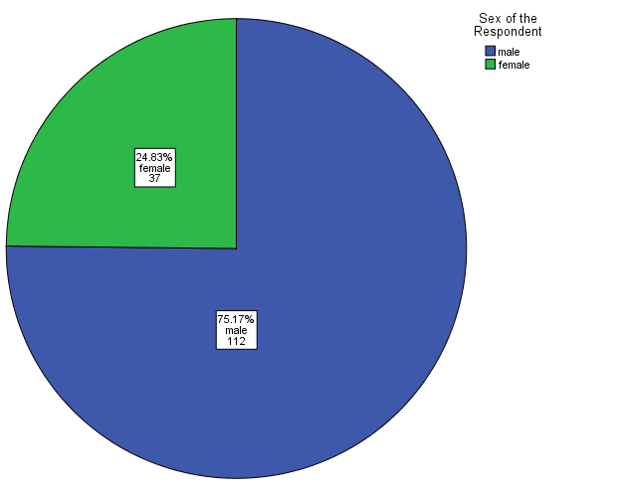

Fig 1: Shows that among the total respondent; 112(75.17%) were male, 37(24.83%) were female.

**Fig 2: Distribution of the respondent on marital status**

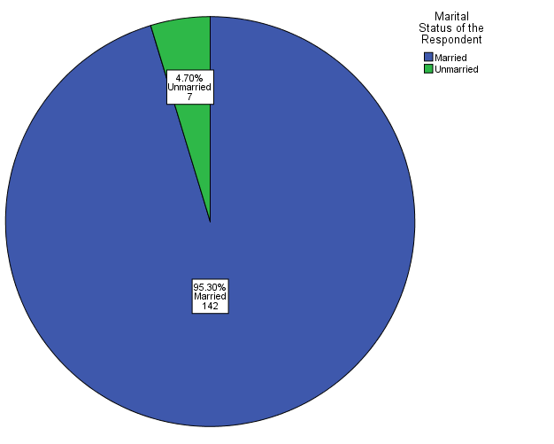

Fig 2: Shows that among the total respondent; 142(95.30%) were married and 7(4.70%) were unmarried.

**Table 3: Distribution of the respondent on Educational Status**

|  |  |  |  |
| --- | --- | --- | --- |
|  | | | |
| Educational status | | Frequency | Percent |
|  | Illiterate | 67 | 45.0 |
| Primary education | 47 | 31.5 |
| Secondary education | 35 | 23.5 |
| Total | 149 | 100.0 |

Table 3: Shows that among the total respondent; 47(31.5%) were primary educated, 35(23.5%) were secondary education and 67(45%) were illiterate.

**Table 4: Distribution of the respondent on income**

|  |  |  |  |
| --- | --- | --- | --- |
|  | | | |
| Income | | Frequency | Percent |
| Valid | 5000-7000 Taka | 50 | 33.6 |
| 7001-9000 Taka | 47 | 31.5 |
| 9001-11000 Taka | 35 | 23.5 |
| 11001-13000 Taka | 8 | 5.4 |
| 13001-15000 Taka | 9 | 6.0 |
| Total | 149 | 100.0 |

Table 4: Shows that among the total respondent; 50(33.56%) earn (5000-7000) taka monthly, Followed by 47(31.54%) earn (7001-9000) taka, 35(23.49%) earn (9001-11000) taka, 9(6.04%) earn (13001-15000) taka & 8(5.37%) earn (11001-13000) taka.

**Table 5: Distribution of the Respondent on Duration of Work**

|  |  |  |  |
| --- | --- | --- | --- |
|  | | | |
| Duration of work | | Frequency | Percent |
|  | 6-8 Hours | 85 | 57.0 |
| 9-11 Hours | 37 | 24.8 |
| 12-14 Hours | 27 | 18.1 |
| Total | 149 | 100.0 |

Table5: Shows that among the total respondent; 85(57%) worked for (6-8) hours and 37(24.8%) worked for (9-11) hours and 27(18.1%) worked for (12-14) hours.

**Table 6: Distribution of the respondent on Duration of job**

|  |  |  |  |
| --- | --- | --- | --- |
|  | | | |
| Duration of job | | Frequency | Percent |
|  | 1-5 years | 18 | 12.1 |
| 6-10 years | 26 | 17.4 |
| 11-15 years | 39 | 26.2 |
| 16-20 years | 27 | 18.1 |
| 21-25 years | 14 | 9.4 |
| More Than 25 years | 25 | 16.8 |
| Total | 149 | 100.0 |

Table6: Shows that Among the total respondent; 39(26.2%) had been working this job for (11-15) years followed by 27(18.1%) for (16-20) years, 26(17.4%) for (6-10) years, 25(16.8%) for more than 25 years,18(12.1%) for (1-5) years and 14 (9.4%) for 21-25 years.

**Table 7: Distribution of the respondent on Number of Family member**

|  |  |  |  |
| --- | --- | --- | --- |
|  | | | |
| Number of family member | | Frequency | Percent |
|  | 1-5 Persons | 91 | 61.1 |
| 6-10 Persons | 49 | 32.9 |
| 11-15 Persons | 9 | 6.0 |
| Total | 149 | 100.0 |

Table7: Shows that among the total respondents; 91(61.1%) had (1-5) persons in their family followed by 49(32.9%) had 6-10 persons and 9(6%) had (11-15) persons in their family.

**Table 8: Distribution of the respondent on Condition of the house**

|  |  |  |  |
| --- | --- | --- | --- |
|  | | | |
| Condition of house | | Frequency | Percent |
|  | Own House | 7 | 4.7 |
| Rented House | 124 | 83.2 |
| Terraced House | 7 | 4.7 |
| Semi Terraced House | 1 | .7 |
| Tin shed house | 10 | 6.7 |
| Total | 149 | 100.0 |

Table8: Shows that among total respondent;124(83.2%) lived in rented house followed by 10(6.7%) in tin shed house,7(4.7%) in own house,7(4.7%) in terraced house and 1(0.7%) in semi terraced house.

**Fig 3: Distribution of the respondent on Use of personal protective equipment**

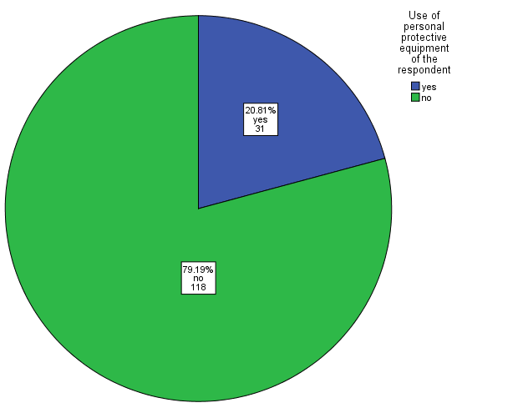

Fig 3: Shows that among the respondent; 118 (79.19%) didn’t use any protective equipment whereas 31(20.81%) used protective equipment.

**Fig 4: Distribution of the respondent on type of personal protective equipment.**

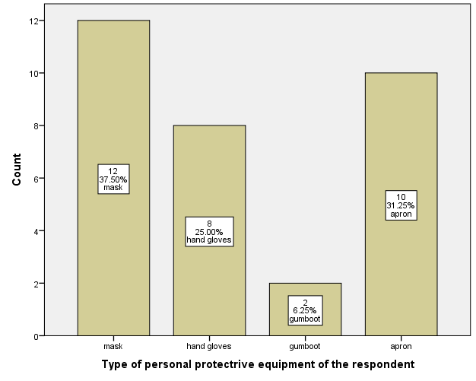

Fig 4: Shows that among the respondents; 12(37.50%) used mask as personal protective equipment followed by 10(31.25%) used apron, 8(25%) used hand gloves and 2(6.25%) used gumboot.

**Table 5: Distribution of the Respondent on Presence of Respiratory Problem**

|  |  |  |  |
| --- | --- | --- | --- |
|  | | | |
| Respiratory Problems | | Present | Absent |
|  | Sore Throat | 15(10.07%) | 134(89.93%) |
| Cough | 21(14.09%) | 128(85.91%) |
| Breathlessness | 9(6.0%) | 140(94.0%) |
| Chest Tightness | 16(10.74%) | 133(89.26%) |
|  |  |  |

Table 5 : Shows that among the respondent; 15(10.07%) had sore throat whereas 21(14.09%) had cough,9(6.0%) had breathlessness and 16(10.74%) had chest tightness.

**Table 10: Distribution of the respondent on Duration of sore throat**

|  |  |  |  |
| --- | --- | --- | --- |
|  | | | |
| Duration | | Frequency | Percent |
|  | less than 1 month | 9 | 60 |
| 1-2 month | 1 | 6.67 |
| 3-4 months | 1 | 6.6.7 |
| More than 4 month | 4 | 26.67 |
| Total | 15 | 100 |

Table 10: Shows that among the respondent; 9(60.0%) had sore throat for less than 1 month followed by 4(26.67%) for more than 4 months, 1(6.67%) for (1-2) months and 1(6.67%) for (3-4) months.

**Table 11: Distribution of the respondent on Duration of cough**

|  |  |  |  |
| --- | --- | --- | --- |
|  | | | |
| Duration of the cough | | Frequency | Percent |
|  | 1-2 weeks | 16 | 83.33 |
| 3-4 weeks | 1 | 5.56 |
| More than 1 month | 4 | 11.11 |
| Total | 21 | 100 |

Table 11: Shows that among the respondent; 16(83.33%) had cough for (1-2) weeks followed by 4(11.11%) for more than 1month and 1(5.56%) for (3-4) weeks.

**Table 12: Distribution of the respondent on Duration of Breathlessness**

|  |  |  |  |
| --- | --- | --- | --- |
|  | | | |
| Duration of Breathlessness | | Frequency | Percent |
|  | 1-6 months | 4 | 44.44 |
| 7-12 months | 1 | 11.11 |
| More than 1 year | 4 | 44.44 |
| Total | 9 | 100.0 |

Table 12: Shows that among the respondent; 4(44.44%) had breathlessness for (1-6) months followed by 4(44.44%) for more than 1 year and 1(11.11%) for (7-12) months.

**Table 13: Distribution of the respondent on duration of Chest Tightness**

|  |  |  |  |
| --- | --- | --- | --- |
|  | | | |
| Duration of chest tightness | | Frequency | Percent |
|  | 1-6 months | 10 | 62.5 |
| 6-12 months | 3 | 18.8 |
| More than 1 year | 3 | 18.8 |
| Total | 16 | 100.0 |

Table 13: Shows that among the respondent; 10(62.50%) had chest tightness for (1-6) months followed by 3(18.75%) for (6-12) months and 3(18.75%) for more than 1 year.

**Fig 6: Distribution of the respondent on presence of eye problem**

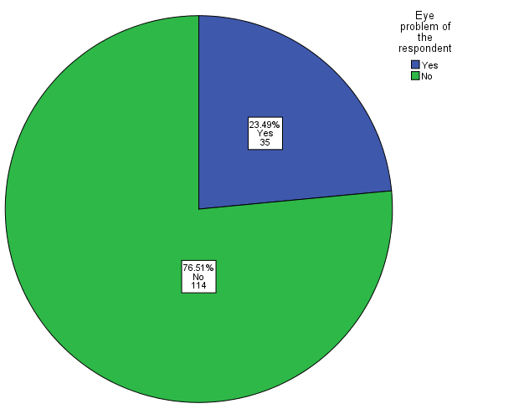

Fig 6: Shows that among the respondent; 114(76.51%) had no eye irritation whereas 35(23.49%) had eye irritation.

**Table 14: Distribution of the respondent on type of eye problems**

|  |  |  |  |
| --- | --- | --- | --- |
|  | | | |
| Type of eye problem | | Frequency | Percent |
|  | Lacrimation | 7 | 20 |
| Redness | 15 | 42.9 |
| Itching | 13 | 37.1 |
| Total | 35 | 100 |

Table 14: Shows that among the respondent; 7(20%) had lacrimation whereas 15(42.9%) had redness of the eye and 13(37.1%) had itching

**Fig 7: Distribution of the respondent on presence of Musculoskeletal problem**

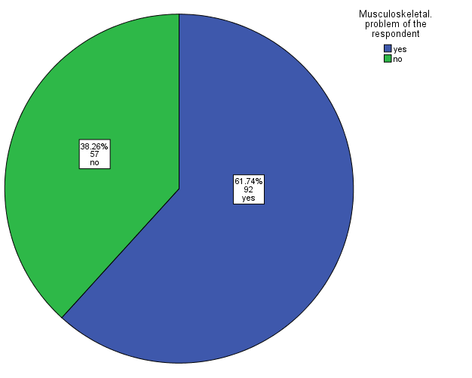

Fig 7: Shows that among the respondent; 92(61.74%) had musculoskeletal problem whereas 57(38.26%) had not.

**Table 15: Distribution of the respondent on Type of Musculoskeletal problem**

|  |  |  |  |
| --- | --- | --- | --- |
| musculoskeletal problem | | Frequency | Percent |
|  | Leg pain | 43 | 46.7 |
| Back pain | 37 | 40.2 |
| Other | 12 | 13.0 |
| Total | 92 | 100.0 |

Fig 15: Shows that among the respondent; 43(46.7%) had leg pain whereas 37(40.2%) had back pain and 12(13%) had other pain.

**Table 16: Distribution of the respondent on presence of Headache**

|  |  |  |  |
| --- | --- | --- | --- |
|  | | | |
| Presence of headache | | Frequency | Percent |
|  | Yes | 20 | 13.4 |
| No | 129 | 86.6 |
| Total | 149 | 100.0 |

Table 16: Shows that among the respondent; 20(13.45) had headache whereas 129 (86.6%) had no headache.

**Table 17: Distribution of the respondent on duration of headache**

|  |  |  |  |
| --- | --- | --- | --- |
|  | | | |
| Duration of headache | | Frequency | Percent |
|  | 1-2 Hours | 11 | 55.0 |
| 3-4 hours | 1 | 5.0 |
| 5-6 hours | 3 | 15.0 |
| More than 6 hours | 5 | 25.0 |
| Total | 20 | 100.0 |

Table 17: Shows that among the respondent: 11(55%) had headache for (1-2) hours followed by 5(25%) for more than 6 hours, 3(15%) for (5-6) hours and 1(5%) for (3-4) hours.

**Fig 18: Distribution of the respondent on presence of skin problem**

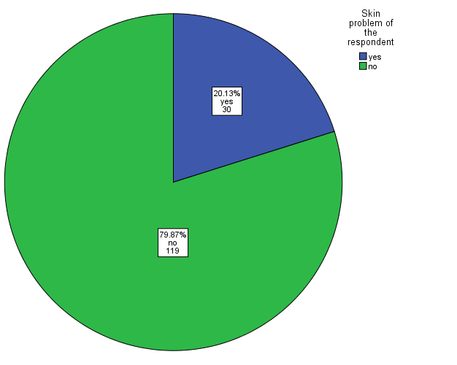

Fig 8: Shows that among the respondent; 30(20.13%) had skin problem whereas 119(79.87%) had no skin problem.

**Fig 19: Distribution of the respondent on type of skin problem**

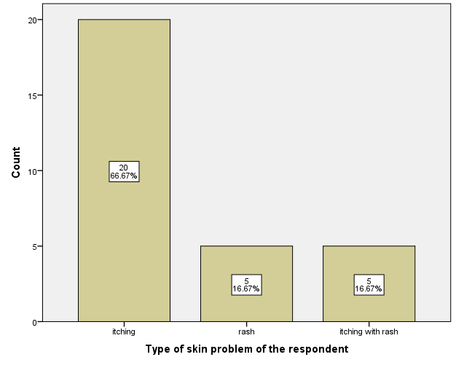

Fig 19: Shows that among the respondent; 20(66.67%) had itching followed by 5(16.67%) had rash and 5(16.67%) had itching with rash.

**Table 20 : Distribution of the respondent on duration of skin problem**

|  |  |  |  |
| --- | --- | --- | --- |
| Duration of skin problem | | Frequency | Percent |
|  | 1-6 months | 14 | 45.2 |
| 7-12 months | 11 | 38.7 |
| More than 1 year | 5 | 16.1 |
| Total | 30 | 100.0 |

Table 1: 8Shows that among the respondent; 14(45.2%) had skin problem for (1-6) months followed by 11(38.7%) for (7-12) months and 5(16.1%) for more than 1 year.

**Fig 21: Distribution of the respondent on presence of Abdominal Pain**

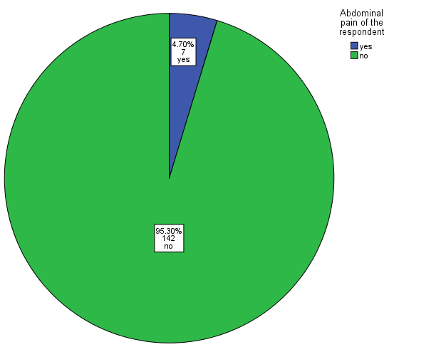

Fig 10: Shows that among the respondent; 7(4.70%) had abdominal pain whereas 142(95.30%) had no abdominal pain.

**Table 19: Distribution of the respondent on presence of Diarrhea**

|  |  |  |  |
| --- | --- | --- | --- |
|  | | | |
| Presence of diarrhea | | Frequency | Percent |
|  | Yes | 2 | 1.3 |
| No | 147 | 98.7 |
| Total | 149 | 100.0 |

Table 19: Shows that among the respondent; majority of the respondent 147(98.7%) had no diarrhea followed by 2(1.3%) had diarrhea.

**Fig 11: Distribution of the respondent on Chewing habit**

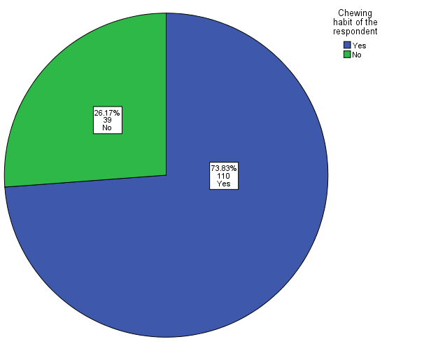

Fig 11: Shows that among the respondent; 110(73.83%) had chewing habit and 39(26.17%) had no chewing habit.

**Fig 12: Distribution of the respondent on type of bad habit**

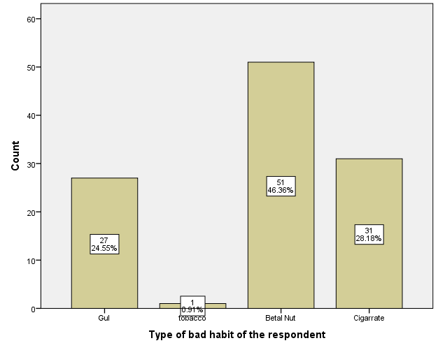

Fig 12: Shows that among the respondent; 51(46.36%) had a habit of taking betel nut followed by 31(28.18%) taking cigarette, 27(24.55%) taking gul and 1(0.91%) taking tobacco.

**Fig 13: Distribution of the respondent on basis of Regular health checkup**

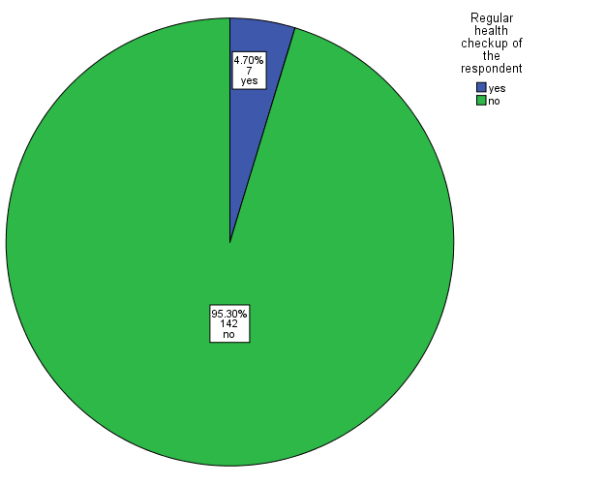

Fig 13: Shows that among the respondent; only 7(4.70%) had a regular health checkup and 142(95.30%) had no regular health checkup.

**Table 20: Distribution of the respondent on T.T vaccination**

|  |  |  |  |
| --- | --- | --- | --- |
| T.T vaccination | | Frequency | Percent |
|  | Yes | 104 | 69.8 |
| No | 45 | 30.2 |
| Total | 149 | 100.0 |

Table 20: Shows that among the respondent; 104(69.80%) was T.T vaccinated whereas 45(30.20%) was not T.T vaccinated.

**Table 21: Distribution of the respondent on feeling of Occupational Safety and security**

|  |  |  |  |
| --- | --- | --- | --- |
|  | | | |
| Feeling of occupational safety and security | | Frequency | Percent |
|  | Yes | 124 | 83.2 |
| No | 25 | 16.8 |
| Total | 149 | 100.0 |

Table 21: Shows that among the respondent; 124(83.2%) had occupational safety and 25(16.8%) had no occupational safety.

**Table 22: Distribution of the respondent on Injury from sharp objects**

|  |  |  |  |
| --- | --- | --- | --- |
|  | | | |
| Injury from sharp object | | Frequency | Percent |
|  | yes | 67 | 45.0 |
| no | 82 | 55.0 |
| Total | 149 | 100.0 |

Table 22: Shows that among the total respondent; 82((55%) had experienced injury from any object during work and 67(45%) hadn’t.

**Table 23: Distribution of the respondent according to Blood Pressure**

|  |  |  |  |
| --- | --- | --- | --- |
|  | | | |
| Blood pressure of the respondent | | Frequency | Percent |
|  | Normal (Systolic:110-130 & Diastolic:70-90) mm Hg | 100 | 67.1 |
| Low blood pressure (Systolic < 110 &/or Diastolic < 70 ) mm Hg | 11 | 7.4 |
| High blood pressure (Systolic > 130 &/or Diastolic > 90) mm Hg | 38 | 25.5 |
| Total | 149 | 100.0 |

Table 23: Shows that among the total respondent; 100(67.1%) had normal blood pressure followed by 11(7.4%) had low blood pressure and 38(25.5%) had high blood pressure.

**Table 24: Distribution of the respondent according to their weight**

|  |  |  |  |
| --- | --- | --- | --- |
|  | | | |
| Weight of the respondent | | Frequency | Percent |
|  | 51-60 kg | 56 | 37.6 |
| 61-70 kg | 60 | 40.3 |
| 71-80 kg | 29 | 19.5 |
| more than 80 kg | 4 | 2.7 |
| Total | 149 | 100.0 |

Table 24: Shows that among the total respondent; 60(40.3%) had weight (61-70) kg followed by 56(37.6%) had weight (51-60) kg, 29(19.5%) had weight (71-80) kg and 4(2.7%) had weight above 80 kg.

**Table 25: Distribution of the respondent according to their height**

|  |  |  |  |
| --- | --- | --- | --- |
|  | | | |
| Height of the respondent | | Frequency | Percent |
|  | 151-160 cm | 54 | 36.2 |
| 161-170 cm | 76 | 51.0 |
| 171-180 cm | 15 | 10.1 |
| 181-190 cm | 4 | 2.7 |
| Total | 149 | 100.0 |

Table 25: Shows that among the total respondent; 76(51%) had height (161-170) cm. followed by 54(.36.2%) had height (151-160) cm. , 15(10.1%) had height (171-180) cm. & 4(2.7%) had height (181-190) cm.

**Table 26: Distribution of the respondent according to their pulse rate**

|  |  |  |  |
| --- | --- | --- | --- |
|  | | | |
| Pulse rate | | Frequency | Percent |
|  | 55-70 beats/min | 45 | 30.2 |
| 71-85 beats/min | 100 | 67.1 |
| 86-100 beats/min | 4 | 2.7 |
| Total | 149 | 100.0 |

Table 26: Shows that among the total respondent; 100(67.1%) had pulse rate (71-85) beats/min. , followed by 45(30.2%) had (55-70) beats/min. , 4(22.5%) had(86-100) beats/min.

**Fig 14: Distribution of the respondent by presence of anaemia**

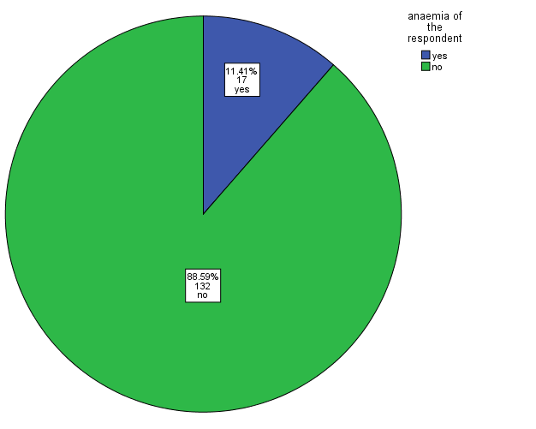

Fig. 14: Shows that among the total respondent; 17(11.41%) had anaemia whereas 132(88.59%) hadn’t.

**Fig 15: Distribution of the respondent by presence of jaundice**

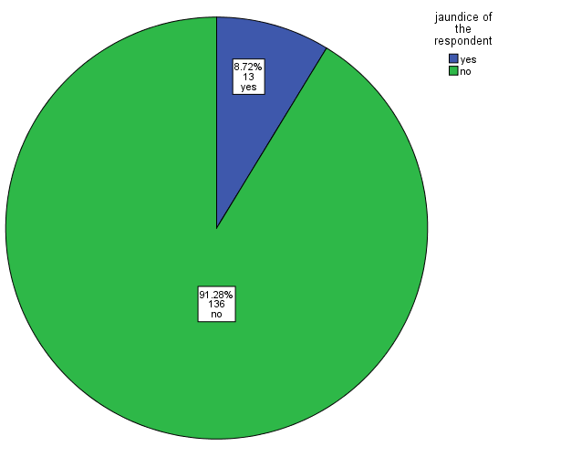

Fig 15: Shows that among the total respondent; 13(8.72%) had jaundice whereas 136(91.28%) hadn’t.

**Table 27: Distribution of the respondent according to their BMI**

|  |  |  |  |
| --- | --- | --- | --- |
| **BMI** | | | |
| Status | | Frequency | Percent |
|  | Under Nutrition | 6 | 4.0 |
| Normal | 112 | 75.2 |
| Over Weight | 29 | 19.5 |
| Obese | 2 | 1.3 |
| Total | 149 | 100.0 |

Table 27: Shows that among the total respondent the BMI status; 112(75.2%) had normal followed by 29(19.5%) had over weight, 6(4%) had under nutrition and 2(1.3%) had obese status.

**Discussion**

**A cross sectional study was done to assess the occupational health hazards of sanitary workers in “Dayaganj Sweeper Colony” and “Dhalpur Sweeper Colony”. It was done on 149 sanitary workers. Among total respondents 112(75.17%)were male,37(24.83%)were female. They belong to middle class family. Among the total sanitation worker 142(95.30 %) were married and 7(4.70%)were unmarried.47(31.5%) have got primary education,35(23.5%) have got secondary education and 67(45%) were illiterate.**

**Among them 50(33.56%) earn taka ( 5000-7000)taka monthly, and 9(6.04%) earn (13001-15000)taka which is not sufficient enough to run a family and rear children.Among the respondent 85(57%) worked for (6-8) hours and 37(24.8%) worked for (9-11) hours and 27(18.1%) worked for (12-14) hours. Among them ;91(61.1%) had (1-5) persons in their family followed by 49(32.9%) had 6-10 spersons and 9(6%) had (11-15) persons in their family. 124(83.2%) lived in rented house followed by 10(6.7%) in tin shed house,7(4.7%) in own house,7(4.7%) in terraced house and 1(0.7%) in semi terraced house.As They are exposed to various type of physical ,chemical, biological hazards. They have a lot of health problem.Among them 15(10.07%) had sore throat,21(14.09%) had cough,9(6.0%) had breathlessness,16(10.74%)had chest tightness,35(23.49%) had eye irritation,92(61.74%) had leg pain,20(13.45%) had had headache,30(20.13%) had skin problem,7(4.70%) had abdominal pain. Out of them 2(1.3%) had diarrhea,1(0.7%) had oral cavity problem.Among them 110(73.83%) had chewing habit, 51(46.36%) had a habit of taking betel nut followed by 31(28.18%) taking cigarette, 27(24.55%) taking gul and 1(0.91%) taking tobacco,17(11.41%) had anemia,13(8.72%) had jaundice 38(25.5%) had high blood pressure.From this study we have seen that 7(4.70%) had a regular health check up,104(69.80%) was T.T vaccinated and their BMI status is : 112(75.2%) had normal followed by 29(19.5%) had over weight, 6(4%) had under nutrition and 2(1.3%) had obese status.In our study we have found that 31(20.81%) use protective equipment and 12(37.50%) used mask as personal protective equipment followed by 10(31.25%) used apron, 8(25%) used hand gloves and 2(6.25%) used gumboot.**

**The maximum number of the respondents (35.6%) were in the age group 35-44. Majority of the respondents (95.3%) were married. Another study conducted in Egypt also showed that majority of the respondents were married 138 (92.0%)10.**

**Among the 149 respondents, 47(31.5%) received primary education, 35(23.5%) received secondary education and 67(45%) were illiterate. Another study in Bangladesh similarly showed most were illiterate (73%), primary education came second with 20% and secondary education was least with 7%.11**

**Most of the respondents 85 (57%) was worked for 6-8 hours and 39(26.2%)had a job duration of 11 – 15 years. 91(61.1% )of the respondents had family members (1-5). Another study in Dhaka showed that among the respondent 4(27%) had extended family,11(73%) had nuclear family.1Among 149 workers, 118 (79.18%) had no protective equipment and only 31 (20.82%) used some protective measures. Another study in Dhaka yielded similar results with 87% respondents used no protective equipment11. Among the respondents 12(37.50%) used mask as personal protective equipment followed by 10(31.25%) used apron, 8(25%) used hand gloves and 2(6.25%) used gumboot.**

**Among the respondent 134(89.93%) had no sore throat whereas 15(10.07%) had sore throat. Also found was among the respondent 128(85.91%) had no cough whereas 21(14.09%) had cough. It was found that among those who had cough 15(83.33%) had cough for (1-2) weeks followed by (11.11%) for more than 1 month and 1(5.56%) for (3-4) weeks. Among the respondent 133(89.26%) had no chest tightness whereas 16(10.74%) had chest tightness. Among the respondent 114(76.51%) had no eye irritation whereas 35(23.49%) had eye irritation. Another study in Egypt found eye irritation among 21% of respondents10. Another study in Dhaka showed that 6(12%) had eye irritation, 18(36%) had headaches,7(14%) had jaundice, 10(20%) had rash or itchiness.4**

**Out of the total respondents 92(61.74%) had leg pain whereas 57(38.26%) had no leg pain. A similar study done in Nepal found leg pain among 60% respondents6. Among those who had leg pain 69(74.19%) had leg pain for (1-2) years followed by 13(13.98%) for (3-4) years, 9(9.68%) for (5-6) years and 2(2.15%) for more than 6 years. Another study conducted in Dhaka showed that among the respondent 21(42%) had low back pain.4**

**It was found in the study 30(20.13%) had skin problem whereas 119(79.87%) had no skin problem. Another study in Egypt found skin irritation among 13.8% of respondents 10. Abdominal pain was found in 4.70% of respondents and diarrhea was found in 1.3% of respondents. Only 0.7% had oral cavity problem. Among the respondent 93(62.42%) used cement latrine, 50(33.56%) used terraced latrine, 3(2.01%) used semi-terraced latrine and tin-shed latrine.**

**Chewing or smoking habit was found in 110 (73.83%) and 39(26.17%) had no chewing habit. Out of those that had smoking or chewing habit 51(46.36%) had a habit of taking betel nut followed by 31(28.18%) taking cigarette, 27(24.55%) taking gul and 1(0.91%) taking tobacco. Another study conducted in Dhaka showed that among the respondent 27(54%) had smoking habit,50(100%) had betel chewing habit.4**

**It was found among the respondents that only 7(4.70%) had a regular health checkup and 142(95.30%) had no regular health checkup. 104(69.80%) respondents were vaccinated for T.T whereas 45(30.20%) were not vaccinated for T.T. When asked about how safe they felt during their occupation 124(83.2%) felt had occupational safety and 25(16.8%) felt had no occupational safety. 45% of the respondents had the history of injury due to sharp instrument. Another study in NEPAL ,where 60% scavengers reported to suffer from cuts and wounds in their legs during the time of work.3**

**Clinical examination for anaemia showed 17(11.41%) had anemia whereas 132(88.59%) hadn’t.**

**Examination for jaundice revealed the following results: only 13(8.72%) had jaundice whereas 136(91.28%) did not have jaundice. Another study done in Dhaka found similar results where 14% respondents had jaundice.**

**Conclusion**

The aim of the study was to assess the common health problems of sanitation workers along with the knowledge and attitude about their health conditions. Respondents were from poor and low socio economic status. They had some but not sufficient idea about their occupational hazards. The major health hazards among them were skin problem, respiratory problem, eye problem as well as sore throat, cough, breathlessness, chest tightness , eye irritation ,leg pain, abdominal pain, oral cavity problem and headache. Despite having idea of using PPE they are not conscious enough to use PPE. The study concludes that the health education, awareness and knowledge about the possible risk factors for the health hazards may help to reduce the common health problems among the workers.

Here, it should be mentioned that, this study was not done by the whole country but only by the community medicine department of Dhaka National Medical College and Hospital. The total condition of the sanitation workers’ area in old Dhaka City is not satisfactory.

**Recommendation**

The study highlights some points regarding knowledge, attitude and health problems of sanitation workers in certain areas of Old Dhaka City. They are –

* General education should be ensured to all the workers so that they should be   
   careful about the health status of their own.
* Proper information regarding the personal protective equipment should be given by

using different media and methods so that the workers feel safe during their work.

* Different type of health programs should be organized at the working sites of the

Sanitation workers once in a year so as to encourage their health awareness

* Specific time duration of work should be allocated to the workers.
* GO and NGO should work together to improve occupational safety and health and job security among the sanitation worker.
* The government should distribute health and safety material including necessary equipment like mask, hand gloves, boots, aprons, garbage collecting tools to the sanitation worker.
* It is essential to establish health care centre in every sanitation worker’s colony.
* More research on this topic must be conducted ,especially regarding health care services and facilities of the City Corporation.

**Reference**

1 .Kabir A Farhana N Aleter F Jesmin S Ali A . Sweeping practices , perception and knowledge about occupational safety and health hazards of street sweeper in Dhaka city, Bangladesh : a qualitative inquiry . Int J community ned public health 2015 Aug; 2(3):237-243

2. Ewis AA RahmaMA Mohamed ES Hifnewy TM Arafa AE Occupational Health related morbidities among street sweepers and waste collectors at Beni-Suef, Egypt. . Egyption Journal of Occupational medicine 2013 ; 37(1):79-94

3 . Tara PA . Health problems of scavengers ; the case of kathmondu metropolitan city , Nepal . The third pole , vol. 8-10 ,PP57-61:2010

4 . Porag RS , Acherjee R. A study on Occpational Health and safety of scavenger in Dhaka City : Safety and Right society ; 2013 July. 26p

5. park k.Parks Textbook of preventive and social medicine.21st Edi.M/S Banarsidas bhanot ,Jabalpur,India.2011:p744

6 . sweeper’s lung disease:a cross-sectional study of an overlooked illness among sweepers of Pakistan.Int J chron obstruct pulmon dis.2013;8:193-197

7. Sheikh SH,Aziz S,William GP,Asari F,Waqqar S,Bano S.Hepatitis prevalence of Epidemic Magnitude Among Sanitary Worker in Pakistan.IOSR-JDMS..E ISSN:2279-0853,P-ISSN:2279-0861.Voume 13,Issue 6 Ver.I (Jun.2014)pp 58-61

8 .Diagn Res JC. Acute Long Function Response to dust in street sweepers. 2013 Oct ; 2126-2129

9 .Watt MMI , watt SJ, Seaton A Erisode of toxic gas exposure in sewer workers . Occup . Environ Med.1997 Apr;54(4): 277-280

10. Sabde YD , Zodpey SP , A study of morbidity pattern in street sweepers : a cross- sectionstudy . India J community med . 2008 Oct; 33 (4): 224-228

11 .Gong Y , YuJ , Zhang X, Liong Y. Occupational Safety and Health Status of Sanitation Workers in Urban Areas : A pilot study from Wuhan, china. International Journal of Occupational safety and Ergonomics 2013 , Vol. 19 , No. 3, 435-442

12. Risk Factors for chromic diseases among road sweepers in Bangkok . Southeast Asian J Trop Med Public Health.1997 mar; 28(1):36-45

13. https://osha.europa.eu/en/tools-and-publications/publications/literature_reviews/eleaming_workers_and_OSH

14 .Masud MR, Network Nederland The life and Days of (Dalit) Sweepers in BD , Daily Jugantor BD , 2006 April : P1

15 .Smilee JS , DHanyakumar G, vivian , Ajay K.T , Suresh Y.B . Acute Long Function Response to Dust in Street sweepers. Journal of climical and Diagnostic Research . 2013 Oct , Vol-7(10): 2126-2129

16. Tiwari RR , Occupational health hazards in and sanitary workers Indian Journal of Occupational and Environmental Medicine – December 2008- volume 12-Issue 3

17 .Anwar SK / Mehmood N ,Nasim N, Khurshid M ,Khurshid B , Sweeper’s lung disease : u cross-section study of on overlooked illness among sweepers of Pakistan , International Journal of COPD 2013:8 193-197

18. Pintakhem K, siriwong W , Prevalence rate and risk factors sociated with health hazards to select the magnitude of health problems among street sweepers in chiang rai province , Thailand . IOSR Journal of Environmental Science Toxicology and Food Technology e-ISSN:2319-2402, P-ISSN:2319-2399. Volume 9 , Issue 7 ver: 2(july.2015)pp 15-18

19.

[https://en.wikipedia.org/wiki/Health_care_access_among_dalilitinindia](https://en.wikipedia.org/wiki/Health_care_access_among_dalilitinindia 20)

[20](https://en.wikipedia.org/wiki/Health_care_access_among_dalilitinindia 20) .[http://www.dhakatribune.com/bangladesh/2014/may/23/dalit community in acute water,sanitation](http://www.dhakatribune.com/bangladesh/2014/may/23/dalit%20community%20in%20acute%20water,sanitation) crisis

21 . ssWatt MM , Watt SJ , Sector A . Episode of toxic gas exposure in sewer workers occup Environ med 1997; 54:277-80

22. WWW.enmcl.com/Resourses/Document/AGRAWAL_Vivek_study_on_social_security-of_sanitary_workers.pdf

23. Rahman M,Alamgir AKM, Hafez MA.Rashid, Kabir, Hyder’s Textbook of Community Medicine and Public Health.5th Edi.MAH Publishers ,Dhaka.2013p: 208-223

24 .Mariammal T.,Jaisheeba AA,Sornaraj R.,Work Related Respiratiry symptoms and pulmonary function tests observed among contruction and sanitary workers of Thoothukudi.International Journal of PharmTech research.ISSN:0974-4304.July-Sept 2012,Vol.4,No. 3,PP 1266-1273

**Key words: sanitation worker, health problems, socio-economic condition, personal protective equipment.**